**EARLY STAGE (BIRTH – PRE-SCHOOL)**

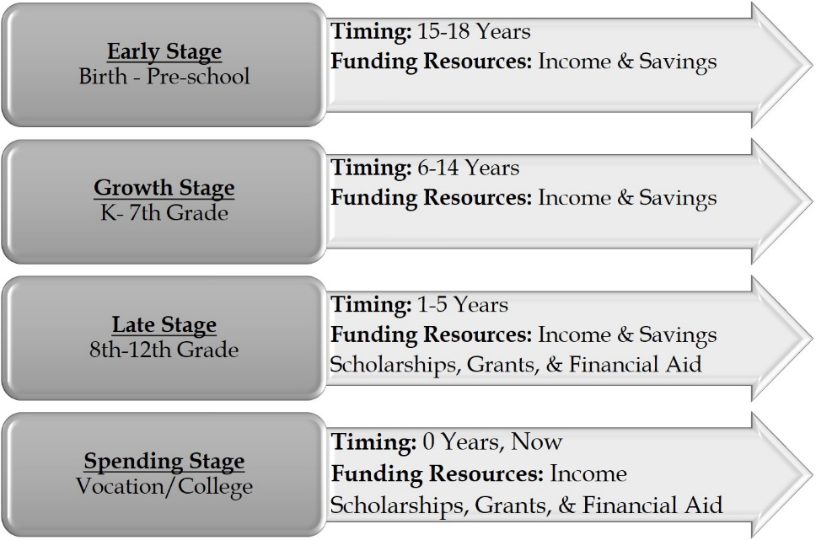

* **Research savings plans in your state.**
* **Start saving money for your child’s education.**
* **Learn about tax advantages.**
* **Learn the basics of college costs and find out what college will cost.**
* **Find out how financial aid and scholarships can help cover college costs.**

**TEMPLATE 10 – TIMELINE CHECKLISTS**

**GROWTH STAGE (K-7TH GRADE)**



* **Start saving money for your child’s education, if you haven’t already. Learn about tax advantages.**
* **Develop strong academic and study habits.**
* **Keep your grades up. Good** grades not only expand your college opportunities but also can help you pay for college with scholarships and grants.
* **Get involved in activities** (playing sports, volunteering and participating in clubs). Activities can lead to scholarships that can make college more affordable.
* **Learn the basics of college costs and find out what college will cost.**
* **Find out how financial aid and scholarships can help cover college costs. Keep in mind that you can apply for some scholarships in the Growth Stage.**

**Middle School Scholars:**

* **Develop a Scholar Profile. Start listing honors, awards, paid & volunteer work (Middle school scholars).**
* Attend college and career fairs.
* **Think about your college choices. Research and v**isit colleges (programs, requirements, costs). Check out this college search tool, College Navigator: https://nces.ed.gov/collegenavigator/.
* **Think about your career options. Use a career search tool like: https://www.mynextmove.org/.**
* Begin thinking about college planning. Check out *College Planning Strategies I Wish Someone Had Told Me* at: www.investnothers.com.

**LATE STAGE (8TH GRADE)**



* **Start saving money for college. Learn about tax advantages.**
* **Find out how financial aid and scholarships can help cover college costs. Keep in mind that you can apply for some scholarships in the Growth Stage.**
* **Develop strong academic and study habits.**
* Take challenging and interesting classes to prepare for high school.
* Find out about high school programs and graduation requirements.
* **Keep your grades up** (3.0 GPA & above) **and monitor your progress.**
* Take an inventory of your interests and passions. Scholarships are not only based on academic achievement.
* **Get involved in activities** (playing sports, volunteering and participating in clubs).
* **Develop a Scholar Profile. Start listing honors, awards, paid & volunteer work.**
* **Narrow down your college choices. Research and v**isit colleges (programs, requirements, costs). Check out this college search tool, College Navigator: https://nces.ed.gov/collegenavigator/.
* **Research career options. Use a career search tool like: https://www.mynextmove.org/.**
* Attend college and career fairs.
* **Learn the basics of college costs and find out what college will cost.**
* Begin your college planning journey. Check out *College Planning Strategies I Wish Someone Had Told Me* at: www.investnothers.com.

**LATE STAGE (9TH GRADE)**



* **Start saving money for college, if you haven’t already. Learn about tax advantages.**
* **Budget for standardized tests, prep courses, college application fees, and other expenses needed before graduation.**
* **Learn the basics of college costs and find out what college will cost.**
* **Find out how financial aid and scholarships can help cover college costs. Keep in mind that you can apply for some scholarships in the Growth Stage.**
* **Discuss options and ideas to pay for college with your family.**
* Develop your college funding plan. Most families use a combination of savings, current income and loans to pay their share of tuition and other costs.
* **Develop and maintain strong academic and study habits.**
* Find out about high school programs and graduation requirements.
* Take challenging and interesting classes while in high school.
* **Keep your grades up** (3.0 GPA & above) **and monitor your progress.**
* Prepare for standardized tests (i.e. SAT and ACT).
* Take an inventory of your interests and passions. Scholarships are not only based on academic achievement.
* **Get involved in activities** (playing sports, volunteering and participating in clubs).
* **Develop a Scholar Profile. Start listing honors, awards, paid & volunteer work.**
* **Narrow down your college choices. Research and v**isit colleges (programs, requirements, costs). Check out this college search tool, College Navigator: https://nces.ed.gov/collegenavigator/.
* **Research career options and college options. Use a career search tool like: https://www.mynextmove.org/.**
* Attend college and career fairs.
* Focus on the college admissions process. Check out *College Planning Strategies I Wish Someone Had Told Me* at: www.investnothers.com.

**LATE STAGE (10TH GRADE)**



* **Start saving money for college, if you haven’t already. Learn about tax advantages.**
* **Budget for standardized tests, prep courses, college application fees, and other expenses needed before graduation.**
* **Learn the basics of college costs and find out what college will cost.**
* **Find out how financial aid and scholarships can help cover college costs. Keep in mind that you can apply for some scholarships in the Growth Stage.**
* **Discuss options and ideas to pay for college with your family.**
* Develop or update your college funding plan. Most families use a combination of savings, current income and loans to pay their share of tuition and other costs.
* **Develop and maintain strong academic and study habits.**
* Take challenging and interesting classes while in high school.
* Find out about high school graduation requirements. Make adjustments, if needed.
* **Keep your grades up** (3.0 GPA & above) **and monitor your progress.**
* Prepare for standardized tests (i.e. SAT and ACT).
* Take the PSAT 10 (High school sophomore) to identify students for scholarships. Organizations such as the American Indian Graduate Center, Asian & Pacific Islander American Scholarship Fund, Hispanic Scholarship Fund, Jack Kent Cooke Foundation, and United Negro College Fund use the PSAT 10 to identify students for scholarships.
* Take an inventory of your interests and passions. Scholarships are not only based on academic achievement.
* **Get involved in activities** (playing sports, volunteering and participating in clubs). Activities can lead to scholarships that can make college more affordable.
* **Start saving money for your child’s education, if you haven’t already. Learn about tax advantages.**
* **Develop strong academic and study habits.**
* **Keep your grades up. Good** grades not only expand your college opportunities but also can help you pay for college with scholarships and grants.
* **Get involved in activities** (playing sports, volunteering and participating in clubs). Activities can lead to scholarships that can make college more affordable.
* **Learn the basics of college costs and find out what college will cost.**
* **Find out how financial aid and scholarships can help cover college costs. Keep in mind that you can apply for some scholarships in the Growth Stage.**
* Identify individuals who can write letters of recommendations.
* **Narrow down your college choices. Research and v**isit colleges (programs, requirements, costs). Check out this college search tool, College Navigator: https://nces.ed.gov/collegenavigator/.
* **Research career options and college options. Use a career search tool like: https://www.mynextmove.org/.**
* Attend college and career fairs.
* Focus on the college admissions process. Check out *College Planning Strategies I Wish Someone Had Told Me* at: www.investnothers.com.

**LATE STAGE (11TH GRADE)**



* **Start saving money for college, if you haven’t already. Learn about tax advantages.**
* **Budget for standardized tests, prep courses, college application fees, and other expenses needed before graduation.**
* **Learn the basics of college costs and find out what college will cost.**
* **Find out how financial aid and scholarships can help cover college costs. Keep in mind that you can apply for some scholarships in the Growth Stage.**
* **Discuss options and ideas to pay for college with your family.**
* **Develop and maintain strong academic and study habits.**
* Take challenging and interesting classes while in high school.
* Find out about high school graduation requirements. Make adjustments, if needed.
* **Keep your grades up** (3.0 GPA & above) **and monitor your progress.**
* Find out the transcript request process at your school.
* Identify individuals who can write letters of recommendations.
* Prepare for standardized tests (i.e. SAT and ACT).
* (Fall) Take the PSAT/NMSQT (High school juniors who take the PSAT/NMSQT are automatically entered into the National Merit Scholarship Program). Organizations such as the American Indian Graduate Center, Asian & Pacific Islander American Scholarship Fund, Hispanic Scholarship Fund, Jack Kent Cooke Foundation, and United Negro College Fund use the PSAT/NMSQT to identify students for scholarships.
* (Spring) Take the SAT and ACT college admissions standardized tests.
* Take an inventory of your interests and passions. Scholarships are not only based on academic achievement.
* **Get involved in activities** (playing sports, volunteering and participating in clubs).
* Research and visit colleges (programs, requirements, costs). Check out this college search tool, College Navigator: https://nces.ed.gov/collegenavigator/.
* Attend college and career fairs.
* Focus on the college admissions process. Check out *College Planning Strategies I Wish Someone Had Told Me* at: www.investnothers.com.

**Summer Before 12th Grade:**

* Register for your FSA ID (your parent will need a FSA ID also) from the Department of Education as you will need it to apply for the FAFSA.
* Start researching outside scholarships and make a note of all deadlines on your Funding/Scholarship Tracking Spreadsheet.
  + Write scholarship essays (if applicable).
  + Request and obtain letters of recommendation.
* Register to take or retake the SAT or ACT college admissions standardized tests.
* **Work and/or volunteer.**
* **Develop or update a Scholar Profile. Start listing honors, awards, paid & volunteer work.**
* **Narrow down your career options and college options. Use a career search tool like: https://www.mynextmove.org/.**
* **Review college applications and start drafting essays during the summer.**
* Develop or update your college funding plan.

Athletes only

* Complete your NCAA Certification Account (DIV I/DIV II)
* Send high school transcripts to NCAA Eligibility Center (after Junior year completed)

**LATE STAGE (12TH GRADE)**



**General:**

* **Start saving money for college, if you haven’t already. Saving some money will help with initial expenses. Learn about tax advantages.**
* **Budget for standardized tests, prep courses, college application fees, and other expenses needed before graduation.**
* **Learn the basics of college costs and find out what college will cost.**
* **Find out how financial aid and scholarships can help cover college costs. Keep in mind that you can apply for some scholarships in the Growth Stage.**
* **Discuss options and ideas to pay for college with your family.**
* Research and apply for outside scholarships and make a note of all deadlines on your Funding/Scholarship Tracking Spreadsheet.
  + Write scholarship essays (if applicable).
  + Request and obtain letters of recommendation.
* Register to take or retake the SAT or ACT college admissions standardized tests.
* Focus on the college admissions process. Check out *College Planning Strategies I Wish Someone Had Told Me* at: www.investnothers.com.
* **Maintain strong academic and study habits.**
* **Keep your grades up** (3.0 GPA & above) **and monitor your progress.**
* Make sure you are on track to meet high school graduation requirements. Make adjustments, if needed.
* **Develop or update a Scholar Profile. Start listing honors, awards, paid & volunteer work.**
* Find out the transcript request process at your school.
* Identify individuals who can write letters of recommendations.
* Research and visit colleges (programs, requirements, costs). Check out this college search tool, College Navigator: https://nces.ed.gov/collegenavigator/.
* **Narrow down your career options and college options. Use a career search tool like: https://www.mynextmove.org/.**

**August – September (Start of Senior Year):**

* **Select your top colleges.**
* **Select your potential college major or field of study (or undecided).**
* **You (and your parents, if applicable) begin gathering financial documents (income, assets, and taxes).**
* Register for your Federal Student Aid (FSA) ID (your parent will need an FSA ID also) from the Department of Education as you will need it to apply for the FAFSA at FAFSA.ed.gov.

**September – December:**

* **Apply to your top colleges for early decision and early action deadlines. Pay close attention to DEADLINES!**
* Write college essays (if applicable).
* Request and obtain letters of recommendation.
* Request your official transcripts (send to colleges).
* The Free Application for Federal Student Aid or [FAFSA](https://www.collegeraptor.com/college-guide/financial-aid/applying-for-financial-aid-fafsa-and-css-profile/) is available on October 1st. You can apply electronically at FAFSA.ed.gov.
* **Complete the CSS/Financial Aid Profile for colleges that require it for early decision and early action at www.collegeboard.org.**
* **Complete any other institution specific aid applications**
* **Complete verification processes required by FAFSA, CSS Profile, or the college.**
* Research and apply for outside scholarships and make a note of all deadlines on your Funding/Scholarship Tracking Spreadsheet. **Pay close attention to DEADLINES!**
  + Write scholarship essays (if applicable).
  + Request and obtain letters of recommendation.

Athletes only

* Update your NCAA Certification Account (DIV I/DIV II).
* Send official transcripts to NCAA the Eligibility Center (September of 12th-grade year).

Performers (Arts, Theater, Instrument, Vocal, Technical)

* Determine audition/interview requirements. Schedule auditions or interviews.
* Prepare a portfolio.
* Add contests to Scholarship list.

**January – June:**

* Continue applying for outside scholarships and make a note of all deadlines on your Funding/Scholarship Tracking Spreadsheet. **Pay close attention to DEADLINES!**
  + Write scholarship essays (if applicable).
  + Request and obtain letters of recommendation.
* **Compare your financial aid awards.** The colleges you apply to will send financial aid award letters by April which will reflect how much and which kinds of aid they are offering you. Your college funding planning specialist can help you make side-by-side comparisons of each college’s aid package or you can use the Compare Your Aid Awards calculator at: <https://bigfuture.collegeboard.org/pay-for-college/financial-aid-awards/compare-aid-calculator>.
* **Notify your selected college as soon as you solidify your decision, and no later than know the college’s deadline. The deadline for most colleges is May 1st.**
* **Select the elements of your financial aid award you choose to accept by the deadline.** Financial aid is limited and is awarded on a first come first serve basis. If you miss the deadline, your gift aid award may go to another scholar. You can, however, ask for an extension if you are waiting to hear from other schools. Each college will decide if it will give you an extension.
* Pay applicable college deposits and fees by the deadline for housing, meals, and other fees.

**Graduate and Celebrate!**

* Register for college courses, if the college permits early registration.
* **Send the final high school transcript to your selected college.**
* **June 30th – If you have not filed the FAFSA for the upcoming academic year, you may only qualify for federal aid.**

Athletes only

* Update your NCAA Certification Account (DIV I/DIV II).
* Send final transcripts to the NCAA Eligibility Center (End of 12th-grade year)

**July/August (Start of College):**

* **Develop a checklist of items needed for college and purchase them over the summer. If you wait until the scholar goes to college, this could be quite expensive.**
* **Prepare to pay the college tuition bill or make payment arrangements, if your costs are not otherwise paid. Costs are billed by the semester.**

**SPENDING STAGE (VOCATION/COLLEGE)**

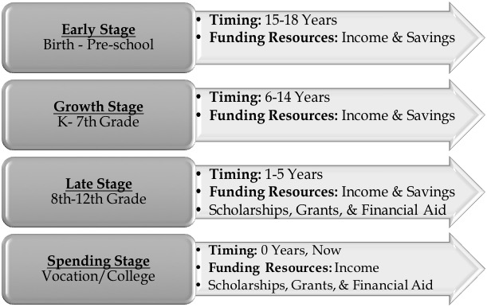

* **Note: If you are planning to apply for vocation/college admission, follow the LATE Stage (12th Grade) checklist for more detailed guidance.**
* **Work and save money for college, if you haven’t already. Saving some money will help with expenses. Learn about tax advantages.**
* **You (and your parents, if applicable) begin gathering financial documents (income, assets, and taxes).**
* Register for your FSA ID (your parent will need an FSA ID also) from the Department of Education as you will need it to apply for the FAFSA at FAFSA.gov.
* The Free Application for Federal Student Aid or [FAFSA](https://www.collegeraptor.com/college-guide/financial-aid/applying-for-financial-aid-fafsa-and-css-profile/) is available on October 1st.  **The last day to file the FAFSA for the upcoming academic year is June 30th.**
* Submit your FAFSA by the financial aid deadline for existing students usually no later than March 1st.
* **Accept your desired financial aid award elements by the deadline.** Financial aid is limited and is awarded on a first come first serve basis, or your award may go to another scholar.
* **Complete financial aid paperwork.** If loans are part of your financial aid package, you’ll have to complete and submit paperwork to get the money.
* Pay applicable college deposits and fees by the deadline for housing, meals, and other fees.
* Register for college courses, if early registration is permitted.
* **Prepare to pay the college tuition bill or make payment arrangements if your costs are not otherwise paid. Costs are billed by semester.**
* **Keep your grades up** (3.0 GPA & above) **and monitor your progress. Scholarships continue to be available and you may have to meet minimum GPA requirements to keep awarded scholarships and for new scholarships.**
* **Develop or update a Scholar Profile or resume.**
* Continue researching and applying for outside scholarships and make a note of all deadlines on your Funding/Scholarship Tracking Spreadsheet. **Pay close attention to due dates and deadlines!**
* Write scholarship essays (if applicable).
* Request and obtain letters of recommendation.
* Find out the transcript request